**We are now located at the Skeet Range office.**

If you are in need of a permit for this upcoming Turkey season, please complete the following before contacting us.

1. Create an iSportsman account at Redstone.iSportsman.net
2. Register your firearms, the pdf for this is under “additional information”
3. Have an Alabama State Hunting License
4. Obtain any form of Hunter Education/ Hunter Safety
5. Watch our RSA Hunter Orientation locations under “additional information”

Our contact information is also listed under the “contact us” tab, but it is listed below. We are going to do our best to get in-touch with each of you in a timely manner.

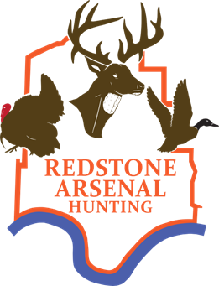Office hours Tuesday – Thursday 10a.m. – 2p.m.

Email for appointments before coming to our office.

*Please include all the email listed below to get a quicker response.

Frederick Anderson – [Frederick.m.anderson.civ@army.mil](mailto:Frederick.m.anderson.civ@army.mil) Ryan Young – [Ryan.k.young3.civ@army.mil](mailto:ryan.k.young3.civ@army.mil)

Layla Wallace – [Layla.d.wallace.ctr@army.mil](mailto:Layla.d.wallace.ctr@army.mil)